15/11/2023

***FOR IMMEDIATE RELEASE***

DOGPEOPLE: A UNIQUE ARTS PROJECT REVIVING GREYHOUND RACING HERITAGE IN COUNTY DURHAM NEEDS YOUR GREYHOUND RACING MEMORIES

DOGPEOPLE, an innovative combined arts project centred around independent greyhound racing, or 'flapping,' in County Durham, has launched and is calling for people to share their stories.

Funded by an Arts Council National Lottery Project Grant and commissioned by No More Nowt, DOGPEOPLE brings together the independent greyhound racing community to co-create a wide array of cultural outputs, including a podcast series, a Story Trail, a Community Exhibition, and a non-fiction book proposal.

This exciting project is spearheaded by award-winning writer, licensed greyhound trainer, and an integral member of the independent greyhound racing community, Dr Louise Powell. Dr Powell has created a variety of work about flapping in County Durham, including BBC Radio 4 Extra audio drama ‘The Pitmen Flappers’, art films and prose essays. She is also a Finalist for the Writer of the Year Award at the North East Culture Awards 2023.

In collaboration with No More Nowt, Redhills CIO, New Writing North, The Story at Mount Oswald, and Wheatley Hill Heritage Centre, DOGPEOPLE is set to breathe new life into the rich heritage of greyhound racing in County Durham.

The work, carried out by Dr Louise Powell and esteemed audio editor Bridget Hamilton, will explore a variety of flapping tracks that once thrived within the boundaries of pre-1974 County Durham. These tracks range from those that now lie derelict to tracks now licensed by the Greyhound Board of Great Britain. To capture the true essence of these historic venues, Louise is eager to interview individuals who attended the following tracks and cherish memories associated with them:
- Belmont
- Coundon
- Easington
- Hartlepool
- Pelaw
- Spennymoor
- Stanley
- Stockton (Belle Vue)
- Sunderland
- Thornley
- Wheatley Hill

Memories and experiences are key to preserving the legacy of greyhound racing in County Durham, and DOGPEOPLE is calling upon people to share their stories.

If you want to contribute memories, please contact Dr. Louise Powell at dogpeoplepodcast@gmail.com or connect with her on Twitter at @louise__powell.

You are also welcome to attend a Community Recording Session at The Annexe of Spennymoor Settlement between 11am-2pm on Saturday 9th December.

DOGPEOPLE is an ambitious project that seeks to unite the past and present of greyhound racing, enriching the cultural fabric of County Durham. Join us on this remarkable journey to celebrate the history, stories, and memories of flapping tracks, and together, let's ensure that the legacy of this unique sport lives on for generations to come.

For media inquiries or additional information, please contact:

Dr Louise Powell
Project Director
dogpeoplepodcast@gmail.com

—-----

About DOGPEOPLE:

DOGPEOPLE is a pioneering combined arts project generously funded by an Arts Council National Lottery Project Grant and commissioned by No More Nowt. Spearheaded by Dr Louise Powell, an award-winning writer, licensed greyhound trainer, and a vital member of the independent greyhound racing community, DOGPEOPLE is dedicated to preserving the rich heritage of independent greyhound racing, or 'flapping,' in County Durham. The project collaborates with various organisations and communities to create a diverse range of cultural outputs, including a compelling podcast series, a QR Code Story Trail, a Community Exhibition, and a non-fiction book proposal. DOGPEOPLE celebrates the vibrant history and stories of greyhound racing tracks in pre-1974 County Durham and invites you to be part of this extraordinary journey.

To get a taste of what DOGPEOPLE has to offer, we invite you to listen to the pilot episode of the DOGPEOPLE podcast, commissioned by Durham Culture County and released in April 2023. Discover the captivating world of greyhound racing heritage by clicking on the following link:https://soundcloud.com/user-287021338/dogpeople-podcast-pilot-episode](https://soundcloud.com/user-287021338/dogpeople-podcast-pilot-episode

About Dr Louise Powell:

Dr Louise Powell is an award-winning writer from Middlesbrough who writes for theatre, short films, audio drama, poetry, podcast and prose. She won the Sid Chaplin Northern Writers’ Award 2023 for her novel-in-progress, and her play Grown Up Writin’ was jointly awarded the Peter Lathan Prize for New Writing 2022. Louise is also a finalist for the Writer of the Year Award at the North East Culture Awards 2023.
Her scripts have been broadcast on BBC Radio 4 Extra and performed at nine theatres,
including The Customs House, Live Theatre and the Tristan Bates Theatre. Louise has
written for commissioned podcasts and three short films. She is a three-time recipient of
Arts Council funding and has received writing commissions from multiple organisations.
Louise is Writer-in-Residence 2023 at Josephine Butler College, Durham University and has participated in talent development schemes with the BBC, BFI and New Writing North, among others.

An internationally and domestically published scholar, she has a PhD in English Literature and holds a Professional Greyhound Trainer’s Licence from the Greyhound Board of Great Britain.
Louise is represented by Elise Middleton at YMU Literary.

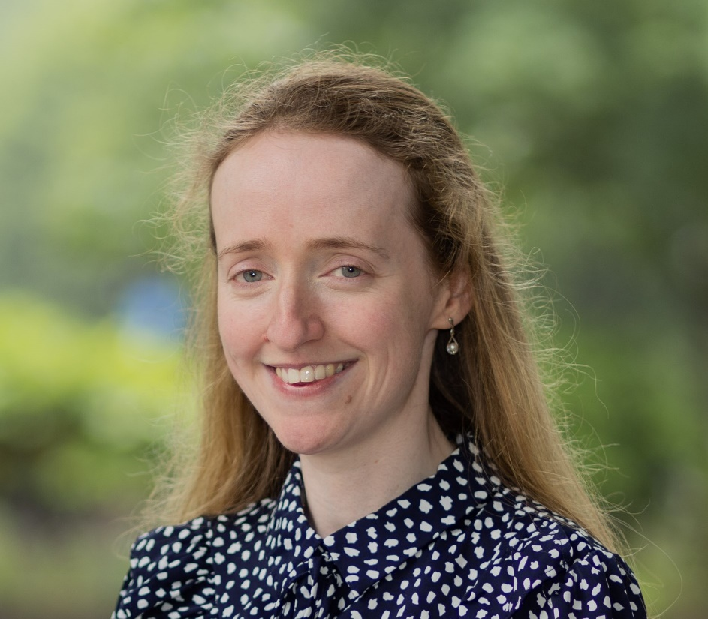
Image Credit: Rob Irish

About Bridget Hamilton:

Bridget Hamilton is a professional writer and audio producer based in Washington, Tyne and Wear. She has a Masters in Radio Production and Management and has made work for the likes of Hexham Book Festival, New Writing North, Kielder Observatory and BBC Radio Three.

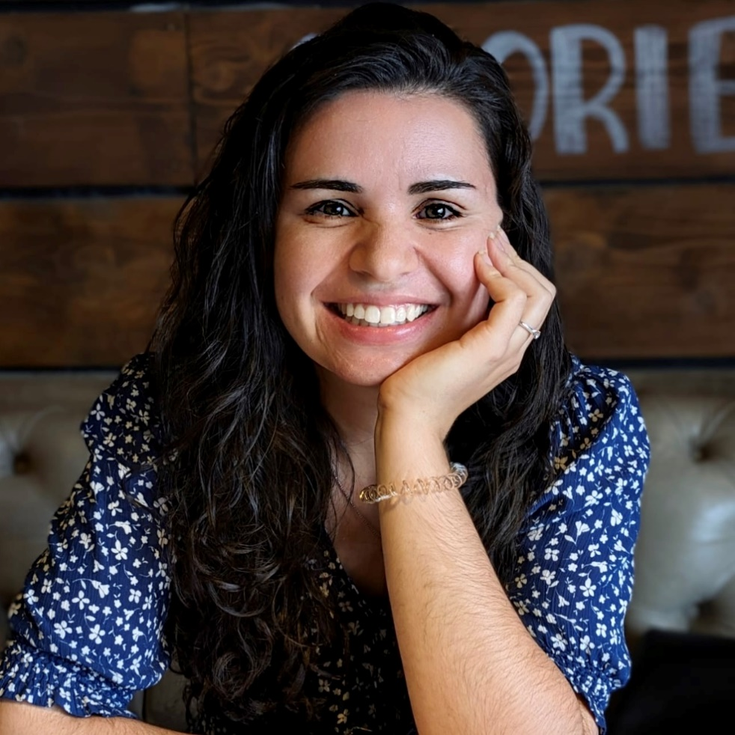
Image Credit: Bridget Hamilton

